PACKET #6

CONTEMPORARY WRITERS PACKET Points: ____ / 70

FEATURED WRITER: JOHN HERSEY HISTORICAL FICTION

CHECK LIST:

- _____/7 Completed Study Guide
- _____/10 Reading Closely For Details
- _____/9 Graphic Organizer (witnesses / tic tac toe)
- _____/14 Vocabulary Development (Activities 1 & 2)
- _____/30 Selection Test

TURN IN THIS COMPLETED PACKET IN ON

DUE DATE:______________________________________

OBJECTIVE: Students will learn literary elements definitions and begin to apply them to reading and their own writing. Students will also read and comprehend Contemporary American writing, the basis for such writing, as well as learn and apply new vocabulary words.

Academic Standards: 1.1.11A Learning to Read Independently
1.1.11E Establish a reading vocabulary
1.1.11F Understand the meaning of and apply key vocabulary words
1.1.11H Demonstrate fluency and comprehension in reading
1.2.11C Produce work in a literary genre
1.3.11A Read and understand works of literature
1.3.11B Analyze relationships, uses, and effectiveness of literary elements
1.3.11C Analyze the effectiveness of author’s use of literary devices
1.3.11F Read and respond to nonfiction and fiction
1.3.11A Write short stories, poems and plays
1.5.11D Write with a command of the stylistic aspects of composition
STUDY GUIDE / INSTRUCTIONS

CONTEMPORARY WRITER: JOHN HERSEY – HISTORICAL FICTION

►LIST TWO INTERESTING FACTS ABOUT JOHN HERSEY, page 1066:

1. _______________________________________________________________

2. _______________________________________________________________

►VOCABULARY:

rendezvous ______________________________________________

abstinence ____________________________________________

notorious ____________________________________________

debris ____________________________________________

sustained ____________________________________________

convivial ____________________________________________

idealist ____________________________________________

►LITERARY ELEMENTS:

setting ______________________________________________

►READING: “A Noiseless Flash” – page 1068

Collection 14 Student Edition pages 1064–1081
Graphic Organizer Reading Closely For Details
A Noiseless Flash John Hersey
Reading Closely for Details Chart Some works require that you do a close reading to understand the text. This means looking for and noting the precise details about people and events.
Choose one witness from Hersey’s account. Then fill in the chart below with the details about that person’s experience.

Witness: ________________________
Precise Details
What was the witness was doing just before the bombing?
How far away from the center of the explosion was the witness?
How was the witness injured? Did he or she receive medical treatment?
What did the witness think had happened?
Were any family members with the witness? Who? Were they injured or killed?

Unit 6: Collection 14
Selection Reading Focus Graphic Organizer
A Noiseless Flash from Hiroshima John Hersey
Reading Closely for Details Choose three of the six witnesses mentioned in the selection, and take brief notes on key details that Hersey provides about each of them. Use an additional sheet of paper if necessary.
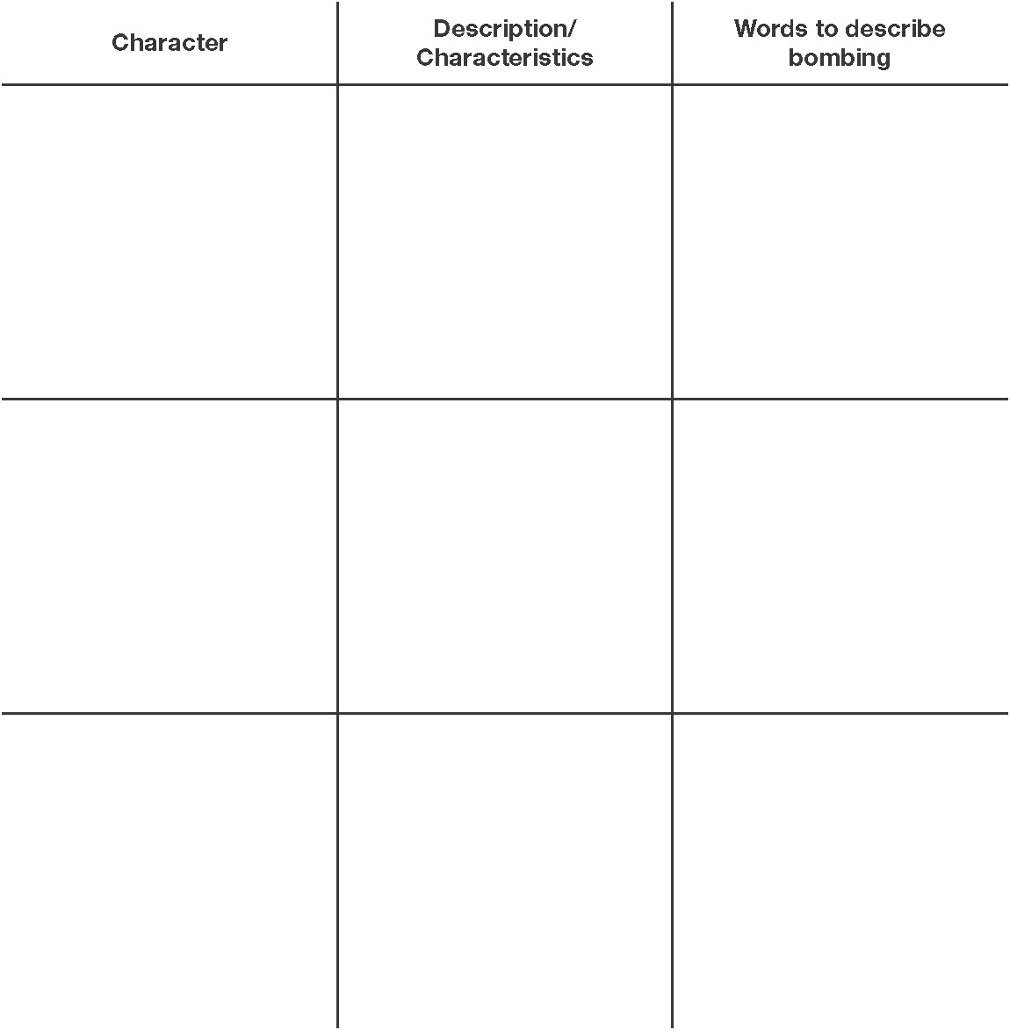
After You Read In the third column of your chart, briefly record some of the words each witness used to describe his or her direct experience of the bombing. Think about how these details contribute to the story as a whole.

Unit 6: Collection 14
Vocabulary Development Skill Builder
A Noiseless Flash from Hiroshima John Hersey
Activity 1: Exploring Deeper Meanings
Choose the statement that provides an accurate example of the meaning of each vocabulary word.
1. debris
A) After the building collapsed, the rescuers dug through the rubble looking for survivors.
B) The group salvaged wood planks from the demolished barn.
2. rendezvous
A) The class met in the old lecture hall on Fridays.
B) Gary told Raphael he would meet him outside of the old lecture hall after lunch.
3. notorious
A) The writer is well known for her highly acclaimed series on magic and wizardry.
B) The writer is well known for writing books with boring storylines and dull characters.
4. abstinence
A) Wally believed that he should not drink alcohol until he was 21.
B) Wally decided to eat a hamburger even though he was a vegetarian.
5. sustained
A) Felix knew that he needed to study every night in order to pass physics.
B) Felix decided to hire a tutor to help him with his physics homework.
6. convivial
A) Toshiko liked to spend her time alone reading her books.
B) Toshiko liked to host parties with all of her friends in attendance.
7. idealist
A) Kanita believed that she could become anything in the United States.
B) Kanita thought that most people were prejudiced in the United States.
Unit 6: Collection 14, Vocabulary Development continued
Activity 2: Changing Contexts
Each vocabulary word from “A Noiseless Flash” is used in the following sentences. Fill in each word where it best fits the context.
Example The sustained silence was difficult for the youngsters who were used to constant noise and talking.
abstinence | notorious | sustained | convivial
debris | rendezvous | idealist

8. I am not a(n) _______________________ who believes in lofty ideas about peace.
9. After the fire, the house was just a heap of charred _______________________.
10. On the tour, we visited the home of a(n) _______________________ murderer.
11. At the weekly meetings, we enjoyed good food and a(n) _______________________ atmosphere.
12. This week, Lynn’s extreme diet included drinking nothing but water with lemon juice and total _______________________ from sugar.
13. The most popular post-game _______________________ point is a fast-food restaurant with a large parking lot.
14. Anna’s _______________________ characterization made her audience believe that she really was an eighty-year-old woman and not a seventeen-year-old high school senior.

Unit 6: Collection 14
Selection Test READING AND LITERATURE
A Noiseless Flash from Hiroshima John Hersey
Comprehension Circle the letter of the best answer to each of the following items.
1. What is Reverend Mr. Tanimoto’s attitude toward the United States?
A) He hates the United States, but likes Americans.
B) He hopes the United States wins the war.
C) He has many American friends, but is loyal to Japan.
D) He has many American friends and hopes to move to the United States after the war.
2. You can infer from Reverend Mr. Tanimoto’s feelings before the bomb exploded that—
A) the Japanese were completely surprised by the bomb
B) few Japanese were concerned about the war or directly affected by it
C) the Japanese were secure in their military superiority
D) many Japanese worried about retaliatory attacks from the Allies
3. When the atomic bomb exploded, almost everyone in Hiroshima—
A) saw a flash of yellow light
B) heard thunder louder than when the B-29s hit Iwakuni
C) saw a flash whiter than anything they had ever seen
D) was unable to hear the sound of the explosion
4. The people that Hersey focuses on can best be described as—

A) government officials
B) ordinary people
C) heroic soldiers
D) wealthy civilians

5. The main theme of “A Noiseless Flash” is that—
A) chance alone determined who survived the attack
B) many people anticipated the nuclear attack and prepared for it
C) most people respond methodically in emergencies
D) all people suffer equally in a war
6. After the bomb is dropped,—

A) medical help is swift
B) soldiers quell the panic
C) the city explodes in flames
D) the sky darkens

Unit 6: Collection 14, Selection Test continued
VOCABULARY DEVELOPMENT Match the vocabulary word in the Word Bank to a group of related words. Write each word on the line. Some vocabulary words will not be used.
debris | rendezvous | sustained | convivial
abstinence | notorious | idealist
7. jovial; sociable
8. principled; optimist
9. restraint; avoidance
10. assignation; meeting
11. prolonged; unabating
Vocabulary Skill Five word pairs follow. On the line provided, write S if the words are synonyms and A if the words are antonyms.
12. philanthropies : charities
13. hullabaloo : stillness
14. frail : substantial
15. xenophobic : intolerant
16. incendiary : combustive
Literary Focus Circle the letter of the best answer to each of the following items.
17. A characteristic of subjective reporting is—
A) collection of newspaper reports about an event
B) the open expression of personal attitudes
C) a comprehensive analysis of statistics
D) interviews with witnesses to an event
18. If “A Noiseless Flash” had been written subjectively, John Hersey—
A) would have been required to use the first-person point of view
B) would not have used quotations from witnesses
C) would have written about fictional characters undergoing an actual event
D) could have clearly expressed his own opinions
Unit 6: Collection 14, Selection Test continued

19. Writers keep their emotions at a distance with—

A) subjective reporting
B) fictional reporting
C) objective reporting
D) firsthand reporting

Reading Focus Circle the letter of the best answer to each of the following items.
20. What is one point Hersey emphasizes in his description of the actions of the survivors immediately before the atomic bomb exploded?
A) All of the survivors had a plan to survive the explosion.
B) None of the survivors expected Hiroshima to be bombed.
C) All of the survivors were in the immediate area of the explosion.
D) None of the survivors was facing the direction of the explosion.
21. Hersey gives many details about the survivors’ actions before the bomb dropped to—
A) show how minor items or actions determined their fates
B) show how the bomb affected people from all walks of life
C) help readers empathize with the survivors
D) provide well-rounded characterization
22. Why does Hersey tell readers that when Mr. Tanimoto left the ruins of the rayon man’s estate he “noticed . . . that the concrete wall . . . had fallen over—toward the house rather than away from it”?
A) The concrete wall protected the estate, and Mr. Tanimoto, from some of the effects of the explosion.
B) Since the wall fell away from the house, it meant that the house had been hit directly by the bomb.
C) The construction materials used for the estate were so weak that the house collapsed easily.
D) Mr. Tanimoto is so affected by the explosion that he notices every minor detail of his surroundings.

Constructed Response (8 points)
23. Explain how John Hersey blended characteristics of fiction and nonfiction in Hiroshima. How does this combination of genres help Hersey convey his feelings about the atomic attack on Hiroshima? Write a short essay that explains your answer. Support your ideas with details from the selection.
HINT: Remember the difference between fiction and nonfiction. Discuss the feelings author may have, keeping in mind the theme (or lesson) he may be trying to convey in this story.

________________________________________________________________________________
_______________________________________________________________________________________________________________________________________________________________________________________________________________________________________________________________________________________________________________________________________________________________________________________________________________________________________________________________________________________________________________

