Chapter 3: American Free Enterprise
Section 1: Benefits of Free Enterprise
Vocabulary:
profit motive - the force that encourages people and organizations to improve their material well-being
open opportunity - the concept that everyone can compete in the marketplace
legal equality – the concept of giving everyone the same legal rights
private property rights - the concept that people have the right and privilege to control their possessions as they wish
free contract - the concept that people may decide what agreements they want to enter into
voluntary exchange - the concept that people may decide what and when they want to buy and sell
competition - the rivalry among sellers to attract customers while lowering costs
interest group - a private organization that tries to persuade public officials to act or vote according to group members’ interests
patriotism – love of one’s country
eminent domain – the right of a government to take private property for public use
public disclosure laws - laws requiring companies to provide full information about their products
public interest - the concerns of the public as a whole

Summarize each section of Chapter 3 Section 1
A Tradition of Free Enterprise
For centuries people have considered America to be a “land of opportunity” where anyone from any background could be successful through determination and hard work. America has a tradition of social and political commitment to giving people the freedom and flexibility to use their own business ideas to compete in the marketplace. American free enterprise system is based on a free marketplace where producers and consumers make decisions about what to buy and sell.

Constitutional Protections
The Bill of Rights of the Constitution guarantees people certain individual rights and freedoms. It also guarantees important rights that allow people to engage in business activities. Property rights is the most important of these rights. Businesses and corporations receive this same right. The Fifth Amendment protects this right from the federal government and the Fourteenth Amendment protects it from the state governments. The government can still take property from individuals using eminent domain, but they must pay a fair price to the landowners. This protection applies to businesses as well as individuals. The Constitution also spells out how Congress can tax individuals. Under current law, both individuals and corporations must pay income taxes. The Constitution also guarantees people and businesses the right to make contracts. Neither individuals nor businesses can use the political process to get out of contracts. The Constitution protects property rights, contracts and other business activities, and we expect the government to preserve an efficient economy and to serve the public interest.

Basic Principles of Free Enterprise
Our free enterprise economy has several key characteristics including profit motive, open opportunity, legal equality, private property rights, free contract, voluntary exchange, and competition. Profit motive encourages people to improve their material well-being. In a free enterprise system, business owners and managers, not government officials, make decisions on how their business will be run. Maximizing profits is the driving force behind these decisions. Profit motive makes people responsible for their own economic successes (and failures). It also rewards innovation by letting companies grow, and it improves productivity by allowing more efficient companies to be more profitable. Through our strong tradition of open opportunity, we accept that different people and different companies will have different economic outcomes. Economic mobility allows individuals to end up wealthier or poorer depending on how well their business performs. America also gives everyone the same legal rights which allows everyone the opportunity to compete in the economic marketplace. Legal equity maximizes a country’s use of its human capital. People also have the right and privilege to control their own possessions. The rights of free contract and voluntary exchange allows people to make their own decisions about who they do business with and when. All of these rights lead to extensive competition that attracts customers while lowering costs. Competition provides consumers with choices.

The Role of the Consumer
A fundamental purpose of the free enterprise system is to give consumers the freedom to make their own economic choices. Consumers choices signal producers as to what goods they should produce. Interest groups have formed around many economic issues, such as taxation, aid for farmers, and land use. These interest groups help consumers’ wishes be known.

The Role of the Government
It is expected that the government will protect consumers’ property rights, contracts, and other business activities in the free enterprise system. One of the government’s important roles is to make sure producers provide accurate information for consumers so that the consumers can make educated decisions. Educated consumers make a free enterprise work more efficiently. We expect the government: to protect us from unsafe foods and drugs; will make producers tell consumers about harmful aspects of their products; and to operate certain regulatory agencies. Businesses must follow certain environmental protection rules in order to protect the public as a whole. In the name of consumer protection, the government sets manufacturing standards, requires that drugs be safe and effective, and supervises the sanitary conditions in foods which are produced. However, government regulation can have negative effects on both businesses and consumers. Negative effects include rules that are costly to implement; regulations that can stifle competitors; and increased government spending in industries because the government has to hire workers to do the actual oversight. The following is a list of Federal Regulatory agencies:
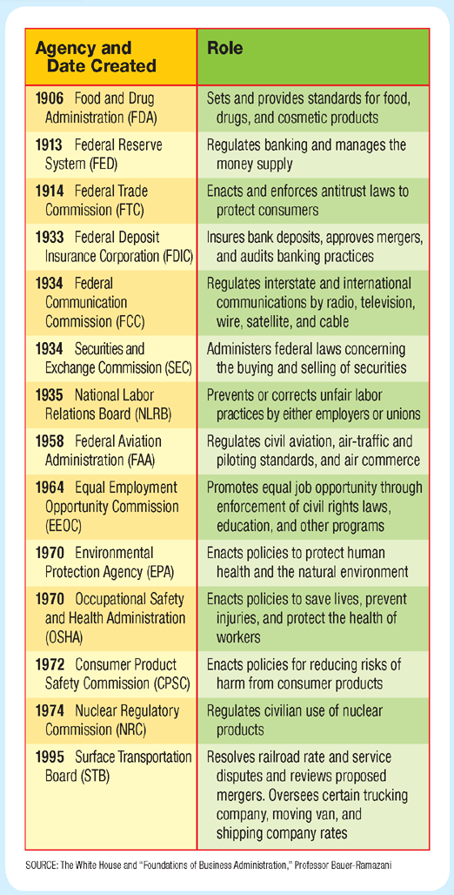
Section 2: Promoting Growth and Stability
Vocabulary:
macroeconomics - the study of the behavior and decision making of entire economies
microeconomics – the study of the economic behavior and decision making of small units, such as individuals, families, and businesses
gross domestic product (GDP) - the total value of all final goods and services produced in a particular economy
business cycle – a period of macroeconomic expansion followed by a period of contraction
referendum – a proposed law submitted directly to the public
obsolescence – situation in which older products and processes become out-of-date
patent – a government license that gives the inventor of a new prouct the exclusive right to produce and sell it
copyright – a government license that grants an author exclusive rights to publish and sell creative works
work ethic – a commitment to the value of work and purposeful activity
technology – the process used to produce a good or service

Summarize each section of Chapter 3 Section 2
Tracking Business Cycles
Macroeconomics studies the behavior and decisions of entire economies; whereas, microeconomics studies the behavior and decision making of small units, such as individuals, families, households, and businesses. GDP or gross domestic product is a way economists measure economic well-being. Economists use the GDP to predict business cycles. Business cycles may last less than a year or continue for many years, but we are always at some point in the business cycle. Where we are in the business affects our daily life, for example if the economy doesn’t create enough jobs, people have trouble finding work, and if prices rise but incomes don’t, then we have trouble buying what we need.

Promoting Economic Strength
Government policymakers aim to stabilize the economy through high employment, steady growth, and stable prices. One aim of federal economic policy is to provide jobs for everyone who is able to work. In the U.S. many economists consider an unemployment rate between 4 and 6 percent to be most desirable, however unemployment rates in the last half of the twentieth century ranged between 3 and 11 percent. * The highest unemployment rate was during the Great Depression when it rose to 24.9 percent. The current unemployment rate in the U.S is about 4 percent. * For each generation to do better than the previous generation, the economy must grow to provide additional goods and services. GDP is a measure of such growth. Another macroeconomic task the government strives for is to keep the economy stable and secure. One indicator of stability is general price levels. The government aims to prevent sudden, drastic shifts in prices. Major fluctuations in price levels cause a chain reaction that the policymakers try to avoid. Another sign of economic stability is the health of the nation’s financial institutions. The federal government monitors and regulates American banks and other financial institutions. Achieving macroeconomic growth and stability is not easy so it is important American citizens understand the macroeconomic process.

Technology and Productivity
The American economy maintains a far higher standard of living, in terms of GDP, than most of the world. Two things that allow this to happen is through the American work ethic and through improved technology. Improvements in technology allow an economy to produce more goods from fewer resources. American history is full of innovations that improved productivity. Inventions are the engine of the free enterprise system. Because innovation is important to maintain America’s technological advantage, the government provides incentives for innovation. The government’s own research institutions produce a steady stream of new technologies that make their way into the marketplace. The government also plays a role in innovation by offering inventors the possibility of making huge profits in the free market, through granting patents and copyrights. Congressional authority to issue patents and copyrights is stated in Article 1, Section 8 of the Constitution.

Section 3: Providing Public Goods
Vocabulary:
public good - a shared good or service for which it would be impractical to make consumers pay individually and to exclude nonpayers
public sector the part of the economy that involves the transactions of the government
private sector – the part of the economy that involves the transactions of individuals and businesses
infrastructure – the basic facilities that are necessary for a society to function and grow
free rider – someone who would not choose to pay for a certain good or service, but who would get the benefits of it anyway if it were provided as a public good
market failure – a situation in which the market does not distribute resources efficiently
externality – an economic side effect of a good or service that generates benefits or costs to someone other than the person deciding how much to produce or consume

Summarize each section of Chapter 3 Section 3
Public Goods
Roads and dams are two examples of public goods. The government collects taxes to pay for these public goods. Any number of consumers can use public goods without reducing the benefits to any single consumer. Cost is critical in determining whether something gets produced as a public good. When a good or service is public, the benefit to each individual is less than the cost that each would have to pay if it were provided privately and the total benefits to society are greater than the total cost. Public goods are financed by the public sector as the private sector would have little incentive to produce public goods. A phenomenon associated with public goods is called the “free-rider problem.” An example of this is the nation’s defense. The government provides a system of national defense; everyone benefits whether they pay or not. Free riders consume what they do not pay for. The free-rider problem suggests that if the government stopped collecting taxes and relied on voluntary contributions, many public services would have to be eliminated.

Market Failures
Free riders are an example of market failure, a situation in which the market, on its own, does not distribute resources efficiently.

Externalities
Externalities are economic side effects of a good or service that generates benefits or coasts to someone other than the person deciding how much to produce or consume. Externalities can be positive or negative. The beneficial side effects of public goods are positive externalities. Some decisions to produce goods and services generate unintended costs, these are the negative externalities. When externalities occur, there is a market failure, because the costs of a good or service are not assigned properly. The government encourages the creation of positive externalities. The government also aims to limit negative externalities.

Section 4: Providing a Safety Net
Vocabulary:
poverty threshold - an income level below that which is needed to support families or households
welfare – government aid to the poor
cash transfers – direct payments of money to eligible poor people
in-kind benefits – goods and services provided for free or at greatly reduced prices
grant – a financial award given by a government agency to a private individual or group in order to carry out a specific task

Summarize each section of Chapter 3 Section 4
The Poverty Problem
While the free market has proven better at generating wealth than any other economic system, that wealth is spread unevenly throughout society. In a society that prefers limited government activity, poverty poses tough questions: What can the government do to combat poverty? What should it do? Is government regulation the best way to help the poor? Since the 1930s, the main government effort to ease poverty has been welfare. The nation’s welfare system began under FDR following the Great Depression. In 1996, Congress made sweeping changes to the welfare system to combat the soaring welfare payments from the 1970s and 1980s.

Redistribution Programs
State and federal governments provide cash transfers to poor, disabled, and retired people. The programs that use cash transfers are: Temporary Assistance for Needy Families (TANF) which replaced AFDC (Aid to Families with Dependent Children); Social Security; Unemployment insurance; and Workers’ Compensation. The government also provides poor people with in-kind benefits such as food giveaways, food stamps, subsidized housing, and legal aid. Medical benefits in the form of Medicare (for people over 65) and Medicaid (for poverty stricken individuals and families) are also provide by the government. Educational programs are also offered to the poor through government funding. Lastly, there are charities and faith-based organizations that also supply aid to the poor and people in need.

